关于荷兰飞利浦Cees Ronda教授学术报告的通知
2015年11月，浙江大学-飞利浦战略合作框架协议、浙江大学-飞利浦-埃因霍温理工大学“智慧之桥计划第三期”签约仪式在浙江大学紫金港校区圆满举行。作为智慧之桥计划子项目，飞利浦（荷兰）将与浙大环资学院沈学优教授团队开展为期二年的室内空气研究合作，荷兰飞利浦Cees Ronda博士（教授、研究员）将于2016年1月19日访问我院环境污染控制技术研究所，并举办讲座。欢迎浙大师生参加！具体如下：
演讲人：Prof. Dr. Cees Ronda
时 间：2016年1月19日（周二）下午15:15-17:00；
地 点：浙江大学紫金港校区农生环组团B127；
内 容：《空气污染的全球污染现状、来源、及空气质量研究》
Lecture on Air quality; Introduction to air purification; Origin of air pollution, air pollution world-wide; Air quality indices.
背景介绍：Prof. Dr. Cees Ronda, Research Fellow (Philips Research Aachen, Germany)
Cees started working with Philips Research since 1986. He is a materials scientist with wide ranging experience in luminescent materials based on a solid theoretical background. He has made important contributions to the development of improved and novel luminescent materials for lamps, LEDs and solar cells, displays and medical applications. Cees has also worked on the understanding of Hg-consumption mechanisms in fluorescent lamps and he has contributed to a more fundamental understanding of electrode operation in fluorescent lamps. In recent years, he has increased the scope of his research interests to include ‘water and air’, aiming at finding solutions to improve the quality of the water people drink and the air people breathe. Projects he has worked on resulted in products such as: Phosphors for Sun tanning Lamps and LEDs, ‘My Reading Light’ and Scintillators.
In 2005, Cees received the Pannenborg Award, in honour of his major contributions to Philips and Philips Research. He has also been granted numerous Innovation Awards over the years.
Cees was also a prime mover in developing the BrainBridge, helping to set up a research co-operation between the Zhejiang University in Hangzhou (China), TU-Eindhoven and Philips Research. He is currently chairman of the program committee that steers the research activities of the BrainBridge.
He is part-time professor at the University of Utrecht, the Netherlands and at Zhejiang University in China.
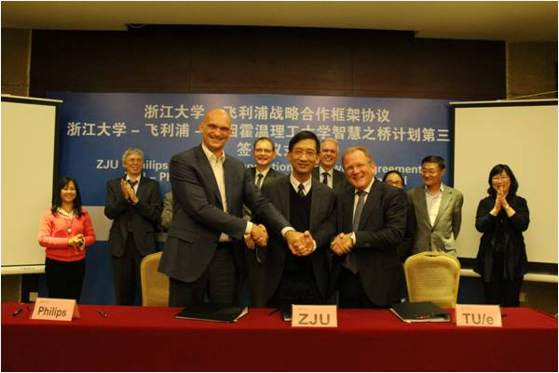
浙江大学环境与资源学院
2016年1月18日

