关于美国环保署（US EPA）David Wong博士学术报告的通知

报告题目：US EPA WRF-CMAQ two-way model with direct aerosol effect: Formulations and Tests
报告人： Dr. David Wong，美国环保署（US EPA） 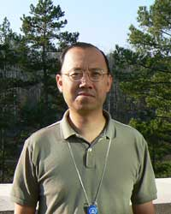
报告时间：2014年11月7日14：00 -15：00 (星期五)
报告地点：浙江大学农生环大楼C216会议室
报告人简介：Dr. David Wong is physical scientist at Atmospheric Modeling and Analysis Division, National Exposure Research Laboratory, U.S. Environmental Protection Agency, Research Triangle Park, NC 27711, US. His research involves in developing US EPA WRF-CMAQ two-way coupled air quality model. David holds a MS in Applied Mathematics from Oklahoma State University and a PhD in Computer Science from North Carolina State University. David won Bronze Medal for Commendable Service Award, 2014, U.S. EPA; Silver Medal for Superior Service Award, 2012, U.S. EPA; Gold Medal for Exceptional Service Award 2009, U.S. EPA.
报告摘要：

A WRF-CMAQ two-way air quality model with direct aerosol effect has been developed at the Atmospheric Modeling and Analysis Division at US EPA. We have used this model in various scenarios: China Beijing area, US Continental 12km domain (1990 - 2010), N. Hemisphere 108 km (1990 - 2010) and California wildfire case, to validate the effectiveness of capturing the aerosol direct effect in the model. This talk will present some test results for WR-CMAQ model for different regions.

浙江大学环境与资源学院
2014年11月6日

