关于美国气象局（NOAA）童全松博士及中国气象局周春红博士学术报告的通知

1．报告题目：Aerosol emissions in the United States: Linking air quality to climate change
报告人： 童全松博士，美国气象局（US NOAA） 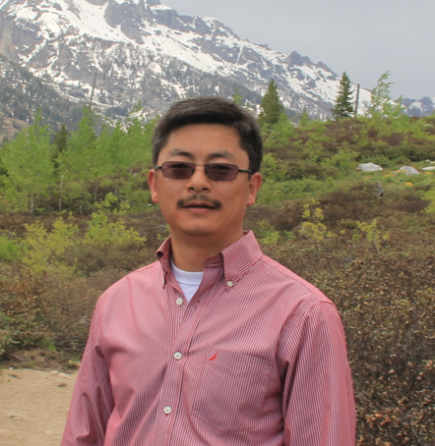
报告时间：2015年6月19日2：00 -3：00 (星期五)
报告地点：浙江大学农生环大楼B110会议室
报告人简介：Dr. Tong has a B.S. degree in chemistry from Ocean University of China, a Ph.D. degree in Atmospheric Sciences from North Carolina State University, and received postdoc training at Princeton University. Dr. Tong is the emission science lead of the US National Air Quality Forecast Capability Program, which provides the numeric air quality forecasting guidance to the nation. He also holds jointly appointments of research professor at George Mason University and University of Maryland at College Park. He supervises a diverse team of undergraduates, graduate students and assistant professors to conduct cutting-edge research on aerosol emissions, including air quality forecasting, remote sensing, and climate assessment. Dr. Tong led the NOAA effort to develop a comprehensive emission modeling system to incorporate thousands of anthropogenic and natural sources to support the US national air quality forecasting operation. He is the lead developer of the dust module for the EPA’s CMAQ model, which is being used worldwide for air quality and climate studies. Dr. Tong is a principal investigator of US National Climate Assessment Indicator Team (2013-2015), and is a member of NOAA Joint Polar-orbiting Satellite System (JPSS) Proving Ground and Risk Reduction Team (2012-2018).

报告摘要：Airborne aerosols exert a myriad of effects on air quality, human health and climate. This talk will discuss recent progress in the research and applications of aerosol emission, which is critical to predicting the life cycle and understand environmental effects of atmospheric aerosols. A brief introduction will be given on the development and refinements of the NOAA emission modeling system used to support the US national air quality forecasting operations, followed by ongoing research efforts to tackle several major uncertainties associated with aerosol emissions.

2．报告题目：中国气溶胶及其数值模拟
报告人： 周春红博士，中国气象局 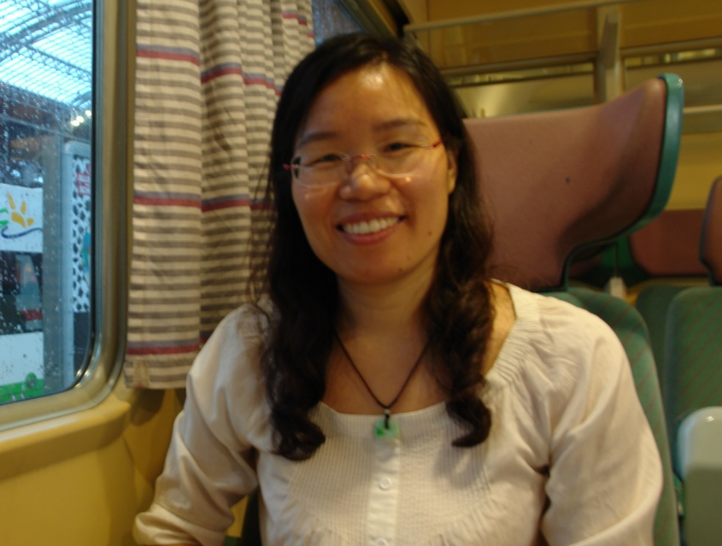
报告时间：2015年6月19日3：00 -4：00 (星期五)
报告地点：浙江大学农生环大楼B110会议室
报告人简介： 1998年毕业于兰州大学获硕士学位，2012年6月获中科院博士学位。1998年至2005年6月在国家气象中心数控室工作。2003年到加拿大学习，2005年7月至今在中国气象科学研究院工作。目前主要研究方向包括化学天气数值预报系统CUACE研发，大气气溶胶数值预报及其影响的研究、雾-霾数值预报技术的研究。她负责开发的亚洲沙尘暴数值预报系统CAUCE/Dust，通过了中国气象局的业务化评估并推广，也为国际沙尘暴计划WMO SDS WAS亚洲和太平洋区域中心的沙尘暴预报预警服务。作为核心人员她完成了中国气象局雾-霾数值预报系统CUACE/Haze-fog的开发，并已经业务化。目前是十二五国家科技支撑计划雾霾观测与数值预报项目负责人。已经主笔或参与的SCI文章有多篇，主编或参与的著作有６部。

报告摘要：中国气象科学研究院发展了在线的包含气态化学和多组分的气溶胶的完全的化学模式系统CUACE（CMA Unified Atmospheric Environmental System），CUACE已经在线耦合到中尺度模式MM5以及中国气象局新一代数值天气模式GRAPES中，并开发了气溶胶的直接辐射和间接辐射反馈。源自CUACE模式的亚洲沙尘暴模式CUACE/Dust以及CUACE/haze-fog已经用于中国气象局沙尘暴数值预报和雾-霾数值预报的业务预报。本报告将介绍CUACE及相关的研究进展。
浙江大学环境与资源学院
2015年6月11日

